**1 The Early Years**

Heinz Nixdorf was born on April 9, 1925, in Paderborn, Germany. He was the son of Walter and Anne Nixdorf and the oldest of five children. His father, a traveling salesman, lost his job at the depth of the Depression. During the war, he was recruited for railway service. In 1944, he was killed when his train was blown up by Polish resistance fighters, thus plunging the family once more into distress. As the eldest son, Heinz helped support the family by working long hours on a nearby farm. These childhood experiences left an indelible mark.

. 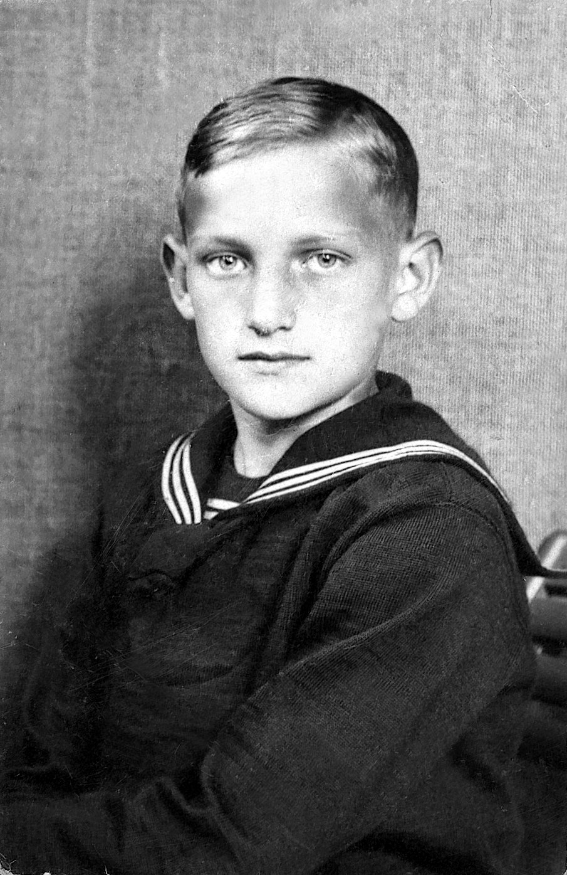

*Heinz at 6. Heinz at 12*

*Pictures courtesy of Nixdorf ComputerMuseumsForum.*

At 14, he graduated from elementary school, scoring very high grades. His mother wanted him to become a teacher because it meant the guarantee of a secure career. She enrolled him in a boarding school in Konstanz, far away from home. Compelled to follow strict rules and regulations, the boy was very unhappy. He wrote a letter to the Ministry of Education in Berlin, explaining that he wanted to become a physicist rather than a teacher.

In 1943, after graduation, he was called up for military service. Stationed in Czechoslovakia, the division in which he served was wiped out. He survived and worked his way back to Paderborn. Now he was able to catch up with the schooling he had missed, and to prepare for his Abitur. A scholarship allowed him to attend the Reismann-Gymnasium in Paderborn, where he was noted as a highly gifted student with a special aptitude for mathematics. His teachers were impressed by his exceptional ability in analytical thinking and by his competitive spirit. In 1947, another scholarship allowed him to enroll in the Johann-Wolfgang-Goethe University in Frankfurt, where he studied physics and mathematics. He also took a course in business management.

Since his mother was unable to pay tuition fees, in order to fund his studies he took a job at the Frankfurt subsidiary of Remington Rand. There his life took an unforeseen turn when he met Dr. Walter Sprick, a data processing expert who ran the company's development laboratory. The 42-year old physicist experimented with automatic symbol identification of electronic adding machines and computer technology. Between 1949 and 1951, he had built an electronic calculator at the University of Kiel. The machine was connected to a Remington Rand card punching machine and had been installed at a savings bank. The device was not only smaller, but much more powerful than the machines sold by IBM and other manufacturers.

The director of the company visualized the potential; he asked him to develop a similar calculator and invited him to move to Frankfurt. Sprick accepted and set to work. But he needed assistance for his project, and was looking for two students capable of providing the necessary help. He contacted one of his friends who recommended Heinz Nixdorf as an extremely intelligent and ambitious young man. For the hourly wage of one DM, he put him to work. With incredible enthusiasm and insatiable curiosity, the young student immersed himself in his job, thus acquiring basic knowledge of electronic technology. But the project was abandoned when the management was given instructions by the US head office to put an end to it.



*Nixdorf and friends at Frankfurt University in 1950.*

Nixdorf was disappointed, but an idea germinated in his mind: IBM and Remington Rand were selling mainframe computers which were accessible only to very large corporations. Small and medium businesses could only afford electromechanical machines to perform multiplication and division by repetitive addition and subtraction. He was convinced that there was a vast and unexplored market for small electronic calculators. Electromechanical machines were very expensive because they required manual assembly. By replacing hand-crafted wiring with mass-produced integrated circuits, the size of the machine would be much smaller and production costs considerably reduced.

Large corporations would also be interested: instead of a centrally operated accounting system which required paperwork to be moved from one office to the other, each department would perform the operations by itself. He tried to convince his mentor to set up a company together. But Sprick felt the risk was too great: he was 43, and the father of four children. Besides, he was a scientist and not a businessman.

Sprick was also convinced that German companies were not ready to buy electronic calculators. Their accounting departments were equipped with mechanical card punching machines. Most of these machines were leased by IBM who ensured their maintenance. Customers were not allowed to make any modifications or to connect any device produced by another company. IBM was in constant contact with its customers, which allowed its engineers to learn about their problems and wishes, and to develop improvements.

But Sprick’s decision had another motive. The German subsidiary of IBM had offered him a well-paid lifetime job. He was given a free hand to conduct his research as he wished. He accepted, and stayed with the company until retirement. Disappointed, Heinz Nixdorf decided to go it alone. Sprick promised to give him every possible support whenever needed, and authorized him to make use of all the technical information contained in his patent. Convinced that he would able to build an electronic calculator all by himself, Heinz returned to Paderborn.1