9 Portrait of the Man

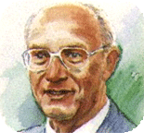

Drawing by Konrad Zuse

For much of the postwar era, Nixdorf epitomized the Wirtschaftswunder, Germany’s extraordinary recovery from the devastation of war. During his lifetime, he became a legend as the visionary young entrepreneur who had the nerve to challenge the giants of the industry. He started out with a moped, a few hand tools and a project. He set up his workshop in the basement of an electric power plant and built it into a one-man global company employing 24000 people. In 1986, at the age of 60, during a company party at the Hannover Fair, he was struck by a heart attack.
He had a project and turned it into a fabulous success. The idea of bringing the computer to the office was in complete contrast to the strategy of the industry leaders. Yet he prevailed, and thereby opened up a whole new market.
The technical knowledge acquired through years of hard work, allowed him to recognize with incredible foresight the value of new ideas and to put them into practice faster than anyone else. The fact that he was exceptionally successful had many causes. Above all, he had a sure touch that gave him the ability to identify opportunities as they presented themselves. He had the extraordinary ability to reduce complex matters to the simplest possible denominator and to concentrate on what was really important. This allowed him to have a clear view of the potential. Once he made a decision, he went ahead regardless the consequences.
He had the sixth sense which gave him the self-confidence to do the right thing at the right moment and to choose the right man at the right time. He recognized and amply rewarded individual merit. He praised and promoted as long as it served his purpose. He also abruptly parted with anyone who was no longer suitable for the job or no more willing to devote himself to the company with the same devotion he demanded of himself. He had no time for superfluous sentimentality: he alone decided what was needed. He set his goal and anyone who wanted to achieve that goal with him had to be prepared to work for it or resign.
He had the courage to take risks, self-confidence, a pioneering spirit, discipline and motivation to venture into untested waters. He regarded work as his mission in life, but also as an opportunity to play a part in the shaping of society. He considered the creation of jobs as one of the most important responsibilities of an entrepreneur.
He had the rare gift of being able to think in simple terms. Instead of being tempted to devise complex solutions to the problems he encountered, his intuitive grasp of the essential issues and his ability to gain insights from them always led him to practice-oriented results.
He paved the way for decentralized data processing. For this, he conceived and created computers that were easy to operate. He held patents, but was not an inventor. He was the entrepreneurial designer of practical technical solutions, manufacturing methods and marketing strategy. He was a social individual. He established institutions and benefits for his employees that were far more generous than was common at the time.

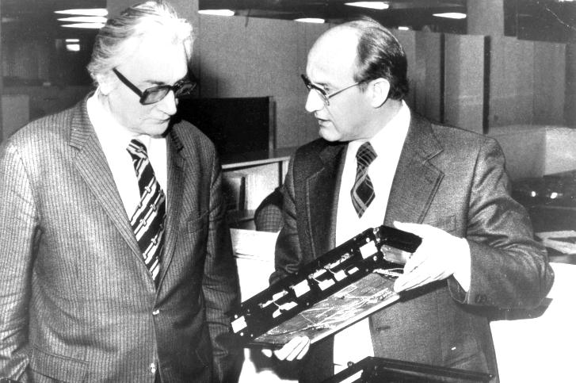
Konrad Zuse and Heinz Nixdorf

Nixdorf wanted his company to remain independent. He set up two non-profit foundations: the Heinz Nixdorf Stiftung and the Stiftung Westfalen were established to hold the shares in Nixdorf Computer AG. After the takeover of Nixdorf Computer by Siemens AG in 1990, these foundations pursued their varied non-profit-making mission. He was both a visionary technician and a businessman. He had an intuitive understanding of corporate finances and quickly grasped the key figures in the balance sheets of his foreign subsidiaries.
Nixdorf tended to be outspoken, which did not always go down well. His overriding interest was the welfare of his fellow human beings. The image of Heinz Nixdorf as a model social entrepreneur continues to live on in the memories of those that were close to him. Nixdorf was an optimist, convinced he could overcome any obstacle. His leadership style and the organizational structure of his company were based on the idea that victory belongs to the bold.
He provided his employees with the best possible working conditions and made sure that everyone got a chance. He was generous, but gave away nothing. Employees who enjoyed his trust were granted great freedom of action and personal responsibility. He particularly valued the foremen and the highly skilled workers for their expertise, commitment and their sense of responsibility.
He was an unusual executive in that he was not only the manager, but owned the business lock, stock and barrel. When Fortune Magazine selected the ten best managers in Europe, he ranked number one. But he did not care for hype. He preferred to live quietly with his family in an inconspicuous flat roof bungalow that was also the headquarters of the company.²⁸
His commanding style impressed those who came in contact with him and was readily accepted by the personnel. But he kept everyone at a distance. Nobody would have dared call him by a nickname.
Heinz Nixdorf possessed all the characteristics of a dynamic entrepreneur: the willingness to take risks, self-confidence, a pioneering spirit, discipline and motivation. He regarded work as his life’s mission, but also as an opportunity to take part in the shaping of society.
As a computer pioneer, he paved the way for decentralized data processing. He envisioned and created computers that were intended to be easy-to-operate tools for the workplace: Even in his later years, he was able to dismantle and reassemble computers during factory tours for visitor groups; the demonstration never failed to astonish.
Whenever he had the occasion to speak his mind publicly, he used to get excited about two issues in particular: both the government subsidies and Siemens. In 1985, the Bonn Ministry of Research and Development approved a DM 20 million grant for a collaborative research project. For the first time, he cooperated with his favorite enemy. ²⁹
He was a social individual in the best sense of the word. He established social institutions and benefits for his employees that were far more generous than was common at the time. Nixdorf wanted his company to remain independent; it should certainly not be subject to control from third parties. Thus the two non-profit foundations, the Heinz Nixdorf Stiftung and Stiftung Westfalen, were established to hold shares in Nixdorf Computer AG. After the takeover of Nixdorf Computer by Siemens AG in 1990, these foundations pursued their varied nonprofit-making goals
He was exceptionally competent with corporate finances, and could grasp the key figures in the balance sheets of foreign subsidiaries or business partners more quickly than many experts. He held patents of his own, but was not a typical inventor. He was the entrepreneurial designer of practical technical solutions, manufacturing methods and distribution processes. He was both a visionary technician and a businessman.
He was convinced that an entrepreneur does not gain legitimacy by the wealth he accumulates, but by the contribution he makes to society. He loathed bureaucrats; in his view, they are an unproductive crowd. He could occasionally be aggressive. He tested his power by challenging the giants of the industry. The accumulation of wealth was not the driving force in his life. It touched a key experience of his early years: the loss of his father and the privations his mother, brothers and sisters had to endure. The memory of these hardships never left him.

